Agenda- To create the report for the best selling product and then we need to create under Data-Admin-Operator-ID and then get the results

First create data type and then sub report

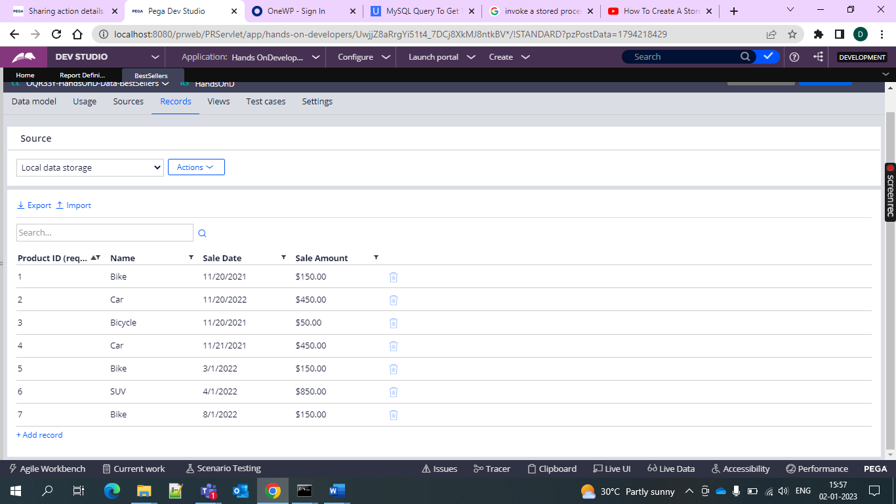

And then go for the sub report

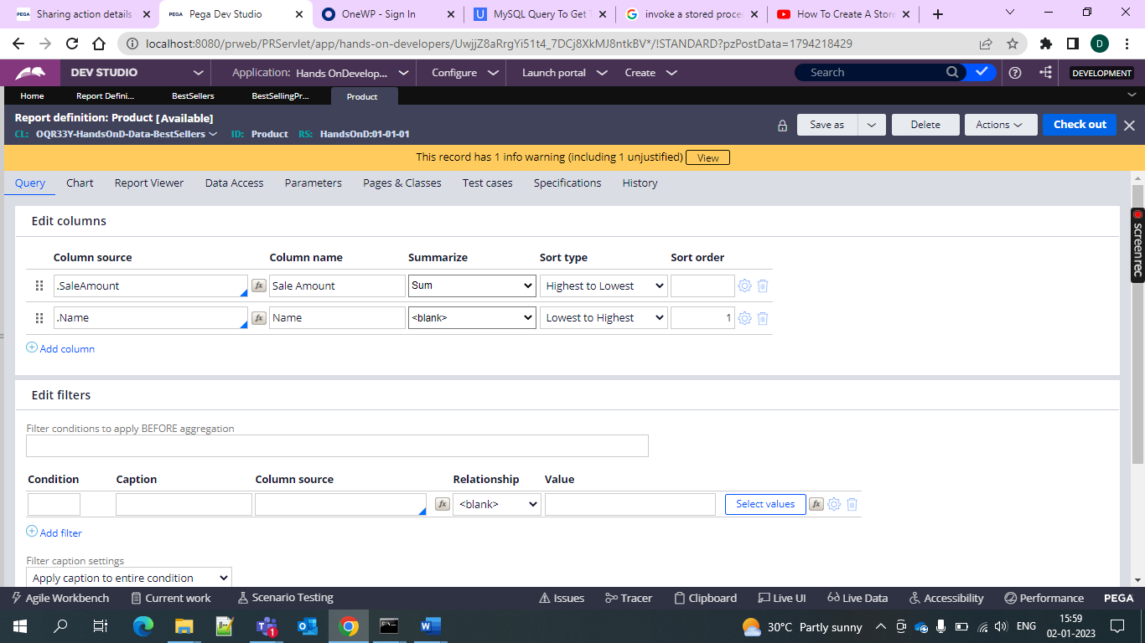

And then create one main report and give this report as sub report

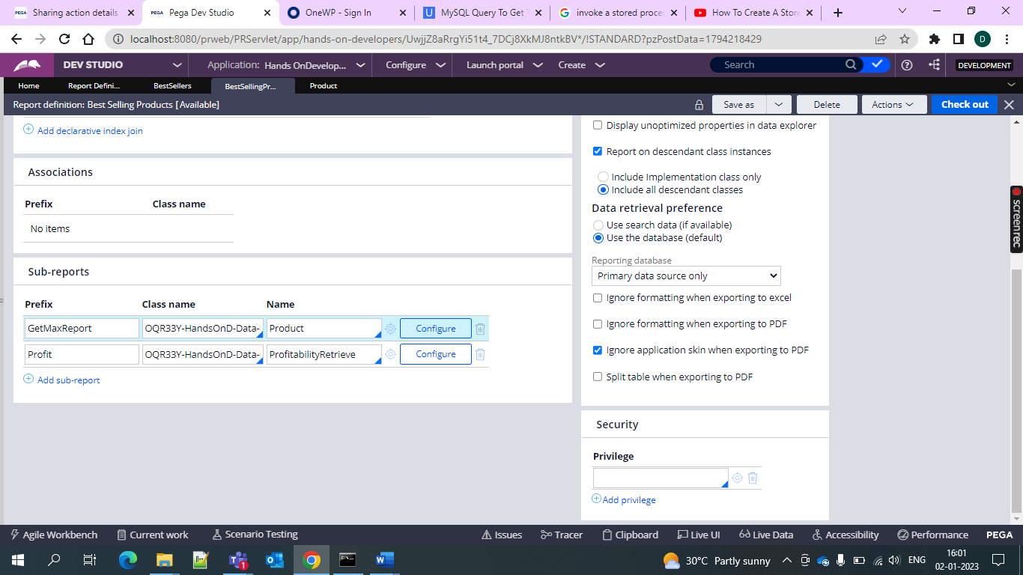

And then go for the configure where we need the 